Name _________________________________ Algebra ws 8.7
Evaluate. No decimals allowed. Show work!
- 3($\frac{1}{2}$)⁴ 2. 8($\frac{2}{3}$)⁻² 3. Y = 4^{x} use the domain: $\left\{-2, -1, 0, 1, 2\right\}$

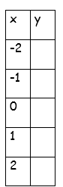
Graph each function.
4. y = $\frac{1}{4}$(2)^{x} 5. Y = 3^{x}
A. growth/decay? ___________ A. growth/decay? ___________
B. asymptote _______________ B. asymptote _______________
C. domain __________________ C. domain __________________
D. range __________________ D. range __________________

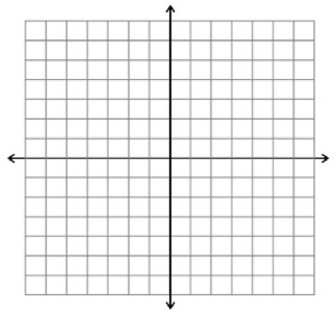

6. y = -2(2)^{x} 7. Y = -3($\frac{1}{2})$^{x}
A. growth/decay? ___________ A. growth/decay? ___________
B. asymptote _______________ B. asymptote _______________
C. domain __________________ C. domain __________________
D. range __________________ D. range __________________
8. y = 2($\frac{1}{3}$)^{x} 9. Y = 2^{x} y = $\frac{1}{2}$^{x}
A. growth/decay? ___________
B. asymptote _______________ intersection ________________
C. domain __________________
D. range ___________________

10. An investment of $2000 doubles every 8 years.
A. write an exponential function: _______________________
B. graph this trend over the next 40 years
C. domain __________
range _______________

11. A car depreciates in value each year. A brand new Explorer has a depreciation model of y = 40000(0.91)^{x}
_____Which statement is FALSE?
- The car depreciates by 91% each year
- The car depreciates by 9% each year
- The decay factor is 0.91
Graph the values over 10 years.
Domain _________ Range _______

