Name _____________________________ Unit 5 TEST REVIEW
Use Pythagorean theorem to solve for the missing side. Leave your answer in simplest radical form:
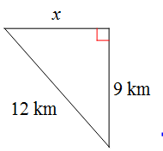
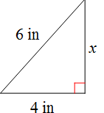
1. 2.

x = _________ x = ________
Use special right triangles to solve for the missing sides:
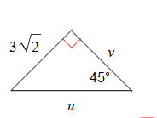
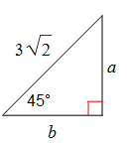
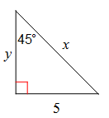
3. 4. 5.

X ________ a _________ u ________
Y ________ b _________ v _________
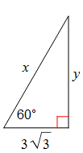
6. 7. 8.
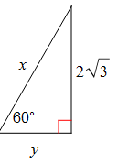
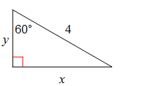

x ________ x _________ x _________
y ________ y _________ y __________
9. 10. 11.
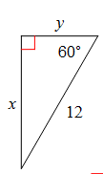
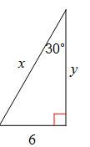
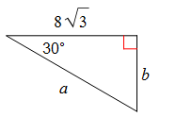

x ________ x _________ a ________
y ________ y _________ b _________
12. Write the ratios: 13. Write the ratios:
Sin A ______ Sin A _______
Cos A ______ Cos A _______
Tan A ______ Tan A _______
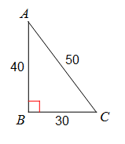
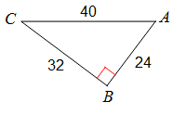

Solve for the missing angles:
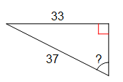
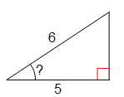
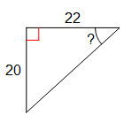
14. 15. 16.

____________ __________ ___________
Solve for the missing sides:
17. 18. 19.

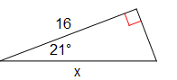
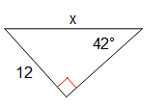
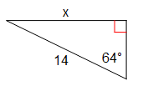

_________ ___________ ___________
20. 21. 22.
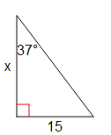
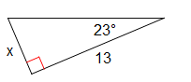
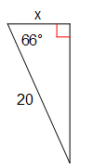

___________ ____________ ___________
Use the Law of Sines:
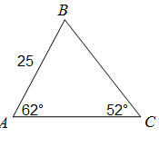
23. AB 24. BC
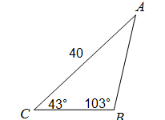

______________ ____________
Use the Law of Sines:
25. $∠$B 26. $∠$C
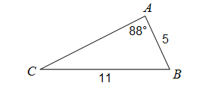
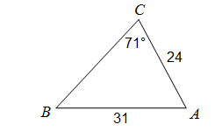

_____________ ____________
Use the Law of Cosines:
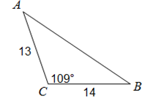
27. AB 28. AB
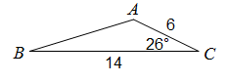

___________ ____________
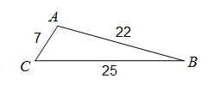
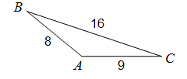
29. $∠$C 30. $∠$A

___________ ____________

Use the trig formula for area of a triangle to find the area:
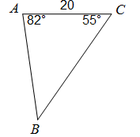
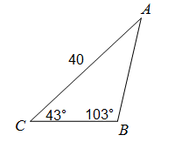
31. 32. 33.
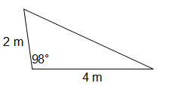
29
28

____________ _____________ ___________
Find the area of the regular polygons:
34. 35.
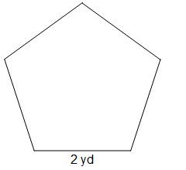
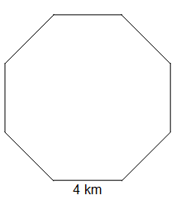

____________ ____________
36. 37.
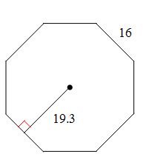
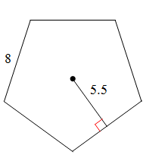

___________ __________
*The sin of an angle = the cos of its complement*
Write an equivalent trig expression for each problem:
38. ________ cos 48 39. _______ sin 24 40. Sin 31 ________
A. cos 42 A. cos 66
B. sin 42 B. sin 66
C. sin 48 C. cos 24
41.

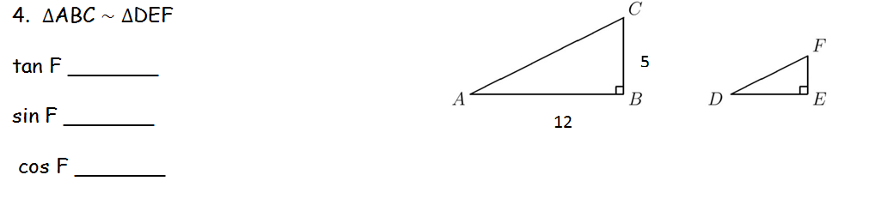
42. $∆$ABC $\sim$ $∆$DEF
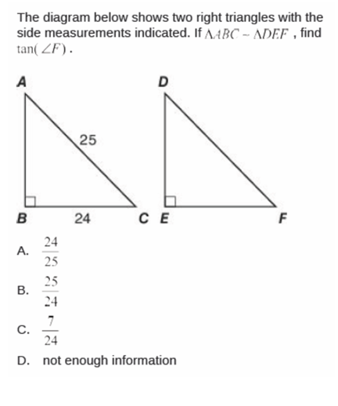
cos B = $\frac{3}{5}$ cos E = __________
43. ____

44. Emily is stuck at the top of a 60 foot ferris wheel. She sees Jacob on the ground at a 58° angle of depression. How far is Jacob from the ferris wheel?

45. Hunter is standing 10 feet away from a tree. He is looking at a little kitten stuck in the tree at a 53°angle of elevation. How high up is the kitten in the tree?

46. A plane is flying at an altitude of 4000 feet. When it begins its descent the pilot sees the airport at a 10° angle of depression. How far will the plane fly to reach the airport?

47. A dog sees a squirrel on a 10 foot fence at a 29° angle of elevation. How far is the dog from the fence?

