Name __________________ Algebra Quadratic Graphing TEST REVIEW
Graph the following quadratic functions:
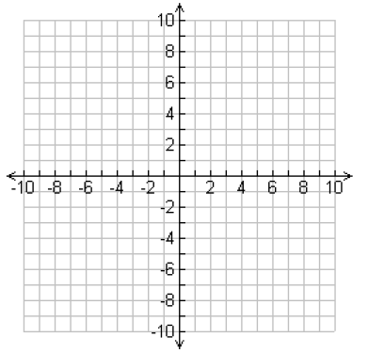
- y $<$ x² - 5 2. y $≤$ -2x² + 1

- y $≥$ $\frac{1}{2}$x² – 4 4. Y $>$ -x² + 6

5. f(x) = -2x² – 10x + 1
AOS ____________
Vertex ___________
y-intercept ____________
domain ________________
range _________________
increasing ______________
decreasing ______________
as x$→-∞, f\left(x\right)→$____________
as x$→∞, f\left(x\right)→$_____________

6. f(x) = $\frac{1}{3}$(x + 3)² – 2
AOS ____________
Vertex ___________
y-intercept ____________
domain ________________
range _________________
increasing ______________
decreasing ______________
as x$→-∞, f\left(x\right)→$____________
as x$→∞, f\left(x\right)→$_____________

7. Write the functions in order from most narrow to widest
A. y = x² – 3x B. y = -3x² + 5x – 1 C. y = - $\frac{2}{3}$x² + 2x – 1
D. y = 5x² – 2 E. y = $\frac{1}{5}$x² + 5
Without graphing, answer the following:
8. y = $\frac{1}{4}($x – 24)² + 50 9. y = -5x² + 28x – 24
A. AOS _________ A. AOS _________
B. vertex ___________ B. vertex ___________
C. y-intercept ________ C. y-intercept ________
D. Domain ___________ D. Domain ___________
E. Range ____________ E. range _____________
F. vertex is max/min? ______ F. vertex is max/min? ______
G. graph is more wide or narrow than y = x²? G. graph is more wide or narrow than y = x²?
_____________________ _________________
H. as x$→-∞, f\left(x\right)→$____________ H. as x$→-∞, f\left(x\right)→$____________
as x$→∞, f\left(x\right)→$_____________ as x$→∞, f\left(x\right)→$_____________

For #10-14 write a function in vertex form:
10. y = -2x² – 12x + 20 11. Y = 5x² + 40x + 12

12. contains (0, 104) vertex is (12, 8) 13. Contains (0, -2) vertex (-1, -7)

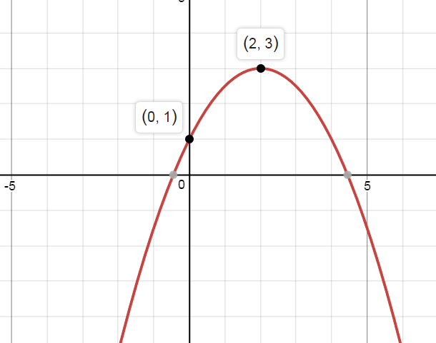
14.

15. A ball is thrown with an initial upward velocity of 50 ft/s. Its height h in feet after t seconds is given by the function h = -16t² + 50t + 6.
A. After how many seconds does the ball reach its maximum height?_______
B. what is the maximum height? __________

16. A small company markets a new toy. The function S = -64p² +2400p predicts in dollars, the total sales S as a function of the price p of a toy.
A. If the price is $25, what are the total sales? __________
B. Which price will produce the highest sales? ____________
C. What is the maximum sales predicted? ________________

17. Write the function in standard form: f(x) = 2(x – 6)² + 12

