Name _____________________________________ Introduction to imaginary numbers
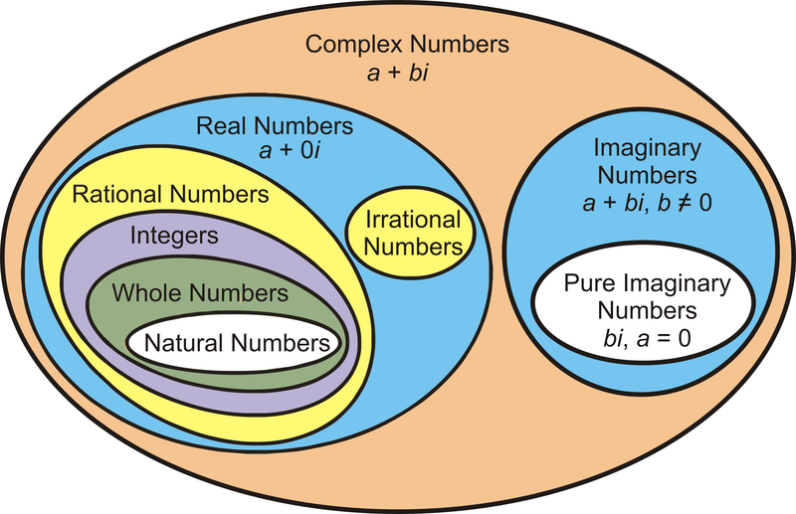

i² = -1

A complex number is of the form a + bi, where a is the real number and bi is the imaginary number.

Simplify negative square roots:
- Rewrite $\sqrt{-a}$ as $\sqrt{a ∙-1}$
- Break down the perfect square if necessary, and simplify
- $\sqrt{-9}$ | - $\sqrt{-196}$ | - $\sqrt{-5}$
- $\sqrt{-80}$ | - $\sqrt{-32}$ | - -4$\sqrt{-20}$

Add or subtract. Write your final answer in the form a + bi.
 | - (4 + 7i) + (2 – 3i) | - (5 – 2i) – (7 – 6i) | - (3 + i) + (-4 – 2i)
- (9 + $\sqrt{-36}$) + (-2 + $\sqrt{-4)}$ |  | - (8 - $\sqrt{-100)}$ - (2 + $\sqrt{-9}$) | - (2 + $\sqrt{-12)}$ + (5 - $\sqrt{-27}$)

i¹ | i⁵
i² | i⁶
i³ | i⁷
i⁴ | i⁸

How can we compute higher powers of I without extending the table?
- I²⁰ | - I³⁷ | - I²⁰³ | - I⁶²

Use properties of exponents and the above table to multiply

- 5i(9i) | - -8i(4i) | - 3i(2i)(5i)
- (3 + 2i)(5 + 3i) | - (3 – i)(3 + i) | - (2 – 5i)(5 – 2i)

Name __________________________________________________ Intro to imaginary numbers
- $\sqrt{-225}$ | - $\sqrt{-1}$ | - $\sqrt{-300}$ | - $\sqrt{-88}$
- $\sqrt{-75}$ | - $\sqrt{-44}$ | - $\sqrt{-48}$ | - -2$\sqrt{-63}$
- (1 + 5i) + (1 – 5i) | - (3 + 2i) – (3 + 2i) | - (2 + 6i) – (7 + 9i) | - (3 + 3i) – (8 – 3i)
- (5 + 4i) – (-1 – 2i) | - (6 – 8i) + (4 – 5i) | - (3 + i) + (3 + i) | - (-1 – 7i) + (-4 – 3i)
(2 + $\sqrt{-1}$) + (-3 + $\sqrt{-16}$) | (4 + $\sqrt{-25}$) – (-5 - $\sqrt{-25}$) | (4 + $\sqrt{-9}$) + (6 - $\sqrt{-49) }$ | (8 + $\sqrt{-1}$) – (3 + $\sqrt{-16}$)
(3 + $\sqrt{-25}$) + (12 + $\sqrt{-121}$) | (2 + $\sqrt{-16}$) – (4 - $\sqrt{-16}$) | (2 + $\sqrt{-8}$) + (3 + $\sqrt{-18}$) | (-1 + $\sqrt{-45}$) + (-1 - $\sqrt{-20})$
- i²⁹ | - i⁴⁷ | - i⁷⁸ | - i⁴⁴
- (3i)(3i) | - (4i)² | - (-3i)(8i) | - (2i)(4i)(6i)
- 4(5i) | - 4i(5i) | - (3i²)(4i²) | - -5i(5i)
- (3 + 6i)(3 – 6i) | - (3 + i)(9 – 3i) | - (2 + 3i)(4 + 7i) | - (2 – 5i)(3 – 6i)

