Name ______________________________ Quiz Review Chapter 6
1. graph the line y = 4  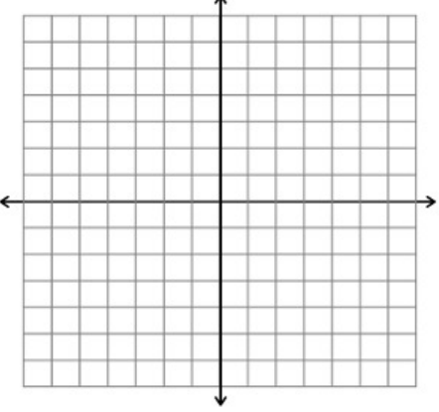  This is a __________ (vertical or horizontal) line with a slope of (0 or undefined) | 2. Graph the line x = 4  This is a __________ (vertical or horizontal) line with a slope of (0 or undefined)
3. Identify the x and y intercepts, then graph:  4x – y = -4  x-int ______ y-int ______ | 4. Identify the x and y-intercepts, then graph:  3y – 4x + 4 = x – 7y – 16  x-int ______ y-int _______
5. Identify the slope and the point the line passes through, then graph:  Y + 4 = -(x – 6)  Slope ______  Point ______ | 6. Identify the slope and the point the line passes through, then graph:  Y – 2 = $\frac{3}{4}$(x + 1)  Slope ______  Point _______
7. Write the equation in standard form using integers:  $\frac{4}{5}$x – 6 = - $\frac{3}{4}$y | 8. Write an equation in standard form using integers:  $\frac{1}{3}$ – x = $\frac{2}{5}$y
9. Write the equation for the line with a slope of -2 and passing through (-4, 12)  A. in point slope form  B. in slope intercept form | 10. Write the equation for the line with a slope of $\frac{3}{7}$ and passing through (14, -21)  A. in point slope form  B. in slope intercept form
11. Write the equation for the line that passes through (-6, 4) and (-4, 2)  A. in point slope form  B. in slope intercept form | 12. Write the equation for the line that passes through (5, 3) and (10, 2)  A. in point slope form  B. in slope intercept form
13. Brittany bought some itunes gift cards. They were $15 or $25. She spent $300.  A. Define your variables:  $15 gift card _______ $25 gift card ______  B. Equation ________________________  C. What are the x-and y-intercepts of your equation? What do they mean in terms of the situation? | 14. Kurt bought some starbucks gift cards. They were $5 or $10. He spent $600.  A. Define your variables:  $5 gift card _______ $10 gift card ______  B. Equation _________________________  C. What are the x-and y-intercepts of your equation? What do they mean in terms of the situation?

