Algebra Quadratic Equations Test Review
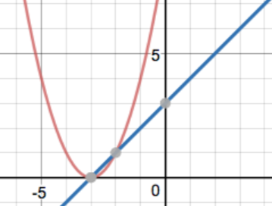  - Name the solution(s) to the system: |  | - Solve the system:  f(x) = $\left\{\begin{aligned}x^{2}+6x+5 \\ 2x+1\end{aligned}\right.$
- Use Quadratic Formula. Leave answer in simplest radical form  2x² + 8x – 2 = x² + 2x – 8 |  | - Use Quadratic Formula. Leave answer in simplest radical form  x² + 2x = -8
- A child tosses a ball and it follows a path of h = -16t² + 10t + 2. How long is the ball in the air? (QF – round to the nearest tenth) |  | - A ball follows the path of  h = -16t² + 40t. Will it ever reach 25 feet? 28 feet? Explain.
- The product of two consecutive integers is 8 more than 3 times the smaller integer. Find the integers. |  | - The product of two consecutive EVEN integers is 10 more than 11 times the smaller integer. Find the integers.
- Write a quadratic model.
X | -5 | -4 | -3 | -2 | -1 | 0 | 1 | 2 | 3 | 4
Y | 0 | 14 | 24 | 30 | 32 | 30 | 24 | 14 | 0 | -18

For #10-12, state the number and the nature of the roots
- x² = -8x – 16 | - 4x² – 5x = 2 |  | - 2x² – 8x + 16 = 0
For #13-15 solve by factoring. No decimals.
- 8x(9x – 4) = 0 | - x² + 2x = 24 |  | - 2x² = 5x + 3

For #16-27 Solve with square roots. Leave all answers in simplest radial form. No decimals.
 | - x² = 81 | - x² = -64 | - x² = 24
 | - x² = -45 | - -9x² + 6 = 30 | - 5x² – 8 = 37
 | - 2(x + 3)² = 32 | - 9x² = 40 | - 6x² + 18 = -78
 | - 3x² + 10 = 4 | - 4(x – 1)² = -100 | - 9(x + 4)² = 45

