Name ______________________________ Algebra Exponential TEST REVIEW
1. _______ 2. Evaluate y = -2(4)^{x} for x = -2
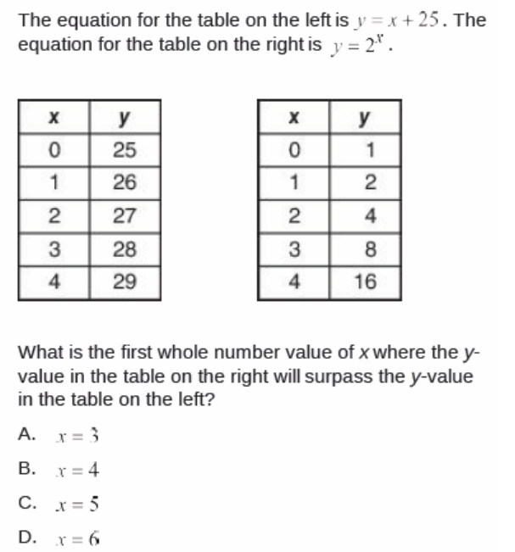
and x = 3. No decimals!

3. Shawn buys a motorcycle. 5 years later he decides to sell it. He uses the following equation to determine his selling price:
Y = 4500(.83)⁵. Describe what each value in the equation represents:
4500 _________________________________
5 ___________________________________
What is the decay factor? ________________
What is the rate of depreciation? _______________

4. Make a table of values and graph f(x) = 2($\frac{1}{4}$)^{x} and h(x) = 0.5$⋅$2^{x} Where do they intersect? (estimate, then use a graphing calculator for the exact value)
X | -2 | -1 | 0 | 1 | 2
F(x)
H(x)
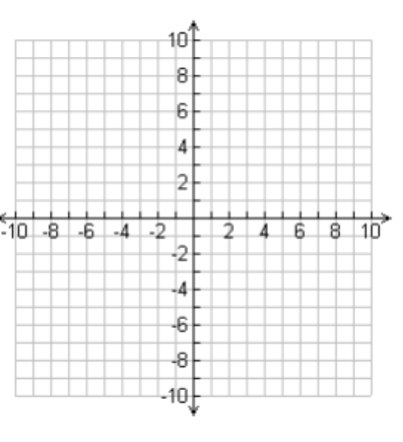

5. You have $300 in birthday money to put into a savings account. You want to use the money in 4 years. Which bank is the best option?
Meerhaeghe Money Maker: 4% compounded annually
Utica bank and trust: 5% compounded biannually
Chieftain Credit Union: 5% compounded quarterly
Bank of Byron: 4.8% compounded monthly

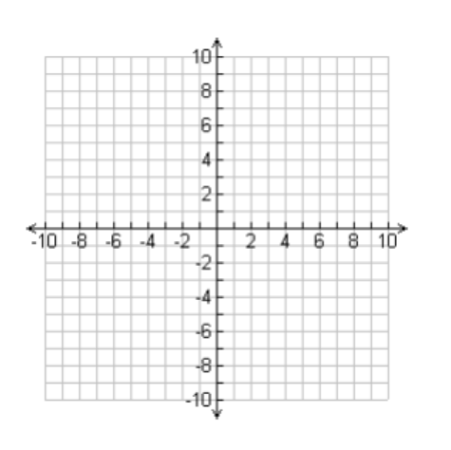
6. graph y = 2(0.4)^{x}
x | -2 | -1 | 0 | 1 | 2
y

What is the domain? ___________________
What is the range? ____________________
What is the asymptote? _________________
Growth or decay? ______________________
For the following problems, consider the fact that your purchases were made the exact day that the item came out.
7. A. You build a new home for $125,000. It increases in value each year by approximately 2%. You use the equation y = 125000(1.02)^{x} to keep track of the value of your home.
What is the domain of the situation? _______________________
What is the range of the situation? _________________________
B. You buy the X Box 1 for your brother. It cost $300. It loses around 7% of its value each year. You use the function y = 300(.93)^{x} to keep track of its value.
What is the domain of the situation? _______________________
What is the range of the situation? ________________________
C. Consider the function y = 2(3)^{x}. There are no constraints on the graph.
What is the domain of the graph? ____________________________
What is the range of the graph? _____________________________

8. Solve for x:
A. 5⁶ = 25^{x} B. 3^{2x} = 9⁴ C. 4^{x} = 2⁶ D. 2^{x} = 16

9. Solve for x: (no decimals!)
A. ${ 3}^{5x-2}$ = ${27}^{4x+3}$ B. $2^{6x}$ = ${32}^{5x-1}$

10. Label each situation as exponential growth, exponential decay, or linear:
A. y = 7(0.1)^{x} ____________________________________
B. y = 7x + 1 ____________________________________
C. y = 0.1(7)^{x} ___________________________________
D. Increase the number of sit ups done each day by 5 _______________
E. Increase the number of miles run each week by 10% ______________
F.
X | -2 | -1 | 0 | 1 | 2
Y | .125 | .25 | .5 | 1 | 2
G.
X | -2 | -1 | 0 | 1 | 2
Y | 7.8 | 6.25 | 5 | 4 | 3.2

H.
X | -2 | -1 | 0 | 1 | 2
Y | 2.7 | 2.95 | 3.2 | 3.45 | 3.7

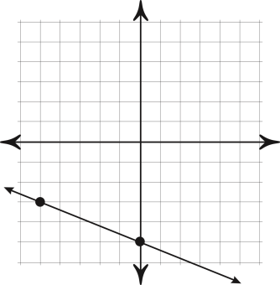
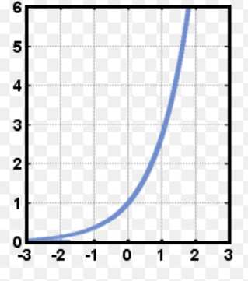
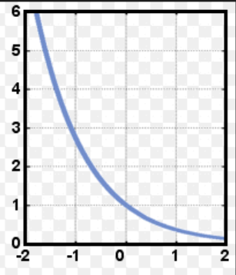
I. J. K.

11. Evaluate f(x) = 4^{x} for the domain $\left\{-3, -2, -1, 0, 1, 2, 3\right\}$ No decimals!

12. g(x) is linear and h(x) is exponential. Write a rule for each function.
g(x) = ______________________ h(x) = ____________________
x | 0 | 1 | 2 | 3 | 4 | 5 | 6
g(x) | 9 | 10.5 | 12 | 13.5 | 15 | 16.5 | 18
h(x) | 3 | 4.5 | 6.75 | 10.125 | 15.1875 | 22.78125 | 34.171885
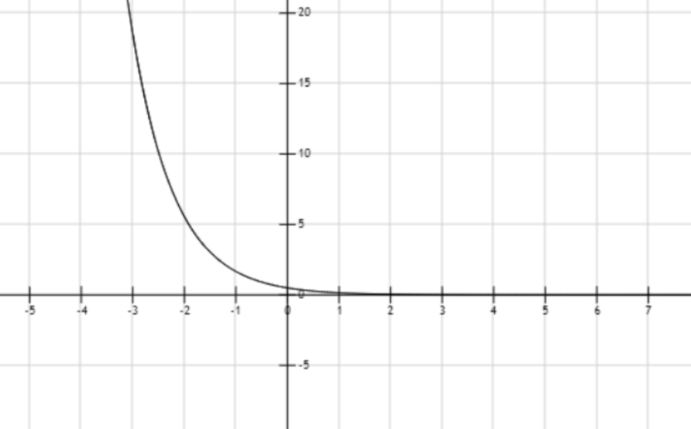
13.

y-intercept ________ x-intercept _______ growth or decay? _________
y = 5, x = ______ y = 10, x = ________

14. A certain kind of bacteria in a lab culture triples in number every 30 minutes. Suppose a culture started with 21 bacteria cells.
A. Write an equation: _________________________
B. How many bacteria will there be in 2 hours? ___________
C. How many bacteria were there 1 hour ago? ____________

15. The half-life of mystery substance 123 is 2 hours. You have 50 mg of mystery substance 123.
A. Write an equation: _____________________________
B. How many mg of mystery substance 123 is there in 6 hours? _________
C. How many mg of mystery substance 123 is there in 15 hours? _________

16. A town has 200 people and it is growing by 24% each year.
A. write an equation: ___________________________
B. How many people will there be in 6 years? ________________
C. How many people will there be in 15 years? ________________
D. How many people were there 3 years ago? _________________

17. A town has 500 people but is losing 5% of its population each year.
A. write an equation: ___________________________
B. How many people will there be in 6 years? ________________
C. How many people will there be in 15 years? ________________
D. How many people were there 3 years ago? _________________

18. y = 40(1.09)^{x}
Is this growth or decay? ________________________
What is the growth/decay factor? ___________________
What is the percent of increase or decrease? ____________

19. y = 20(0.77)^{x}
Is this growth or decay? ________________________
What is the growth/decay factor? ___________________
What is the percent of increase or decrease? ______________
20. (3x)⁰ 21. $\frac{9x^{4}y}{12xy^{2}}$ 22. (5a⁴bc⁶d⁻⁵)²

23. rewrite with a single exponent:
A. 4x²y⁶z⁸ B. 125x⁶y¹⁵z³

24. identify the coefficient, base, and exponent:
A. 50(2)^{x} B. 9x³ C. -2(0.5)⁴

25. (5x⁴)²(2x⁵)³

26. (m^{x})^{y} 27. m^{x}(m^{y}) 28. $\frac{m^{x}}{m^{y}}$

29. You get to choose between two allowance plans, but you may change the plan at any time.
Plan #1: $6 each week
Plan #2: $0.25 for the first week, and it will double each additional week.
You will not be spending any of the money!
- How much will you receive at the end of the 5th week under
Plan #1 _________ Plan #2 __________

- How much total will you have received at the end of the 5th week under
Plan #1 _________ Plan #2 __________

- When should you switch plans? _____________________

30. graph f(x) = -.8(3)^{x}
x | -2 | -1 | 0 | 1 | 2
y

What is the domain? ___________________
What is the range? ____________________
What is the asymptote? _________________
Growth or decay? ______________________

