A1 U3 Systems with Absolute Value Name: _______________________________

Solve the following systems by graphing.
- $\left\{\begin{aligned}y=x \\ y=\left|x-2\right|\end{aligned}\right.$ 2. $\left\{\begin{aligned}y=1 \\ y=-\left|x+2\right|+2\end{aligned}\right.$

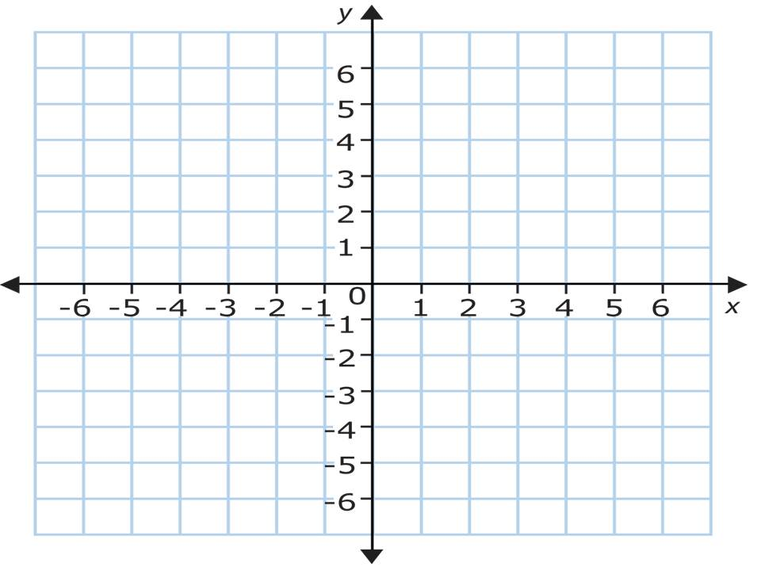

Solve the following systems algebraically.
3. $\left\{\begin{aligned}y=\left|x-3\right| \\ y=-\frac{1}{2}x+3\end{aligned}\right.$ 4. $\left\{\begin{aligned}y=\left|x\right| \\ y=\frac{1}{2}x+3\end{aligned}\right.$

5. $\left\{\begin{aligned}y=\left|2x+2\right| \\ y=x-1\end{aligned}\right.$ 6. $\left\{\begin{aligned}y=\left|x+1\right| \\ y=-x+5\end{aligned}\right.$

7. $\left\{\begin{aligned}y=\frac{x}{5}+1 \\ y=\left|x-2\right|-1\end{aligned}\right.$ 8. $\left\{\begin{aligned}y=-\left|x-1\right|+4 \\ y=\frac{1}{3}x+1\end{aligned}\right.$

