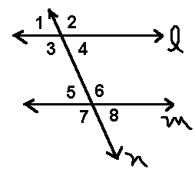
Name __________________________________ Geometry Test Review: Language of Geometry
1. True or False:
A. $∠$1 $≅$ $∠$5 _________
B. $∠$6 $≅$ $∠$8 _________
C. $∠$7 $≅$ $∠$2 _________
D. $∠$1 $≅$ $∠$7 _________

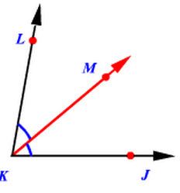
2. Name all angles congruent to $∠$1: __________________________
$\vec{KM}$ bisects $∠$LKJ

3. $∠$LKM = (6x – 10)° and $∠$JKM = (2x + 30)°
x = _____
m$∠$LKM = _______
m$∠$JKM = _______
m$∠$LKJ = ________

4. $∠$LKM = (4x + 6)° and $∠$JKM = (2x + 24)°
x = _____
m$∠$LKJ = ________

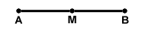
M is the midpoint of $\overline{AB}$
5. $\overline{AM}$ = 12x, $\overline{MB}$ = 8x + 24
X = _____
$\overline{AM}$ = _____
$\overline{MB}$ = ______
$\overline{AB}$ = _______
6. $\overline{AM}$ = 5x - 2, $\overline{MB}$ = 2x + 10
X = _____
$\overline{AM}$ = _____

7. $\overline{AM}$ = 2x + 18, $\overline{MB}$ = 8x
X = _____
$\overline{AB}$ = _______

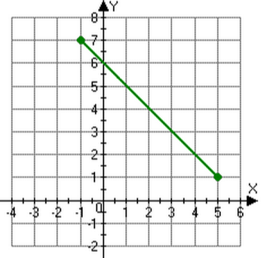
8. use the formula ($\frac{x+x}{2}$, $\frac{y+y}{2}$) to find the midpoint of the segment:
Hint:
Write the coordinates (x, y) of the endpoints first!

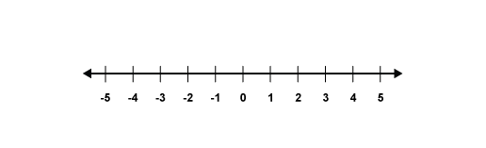
9. Find the midpoint of $\overline{AB}$
B
A

A triangle has coordinates A (2, 1) B (7, 1) and C 2, 4)
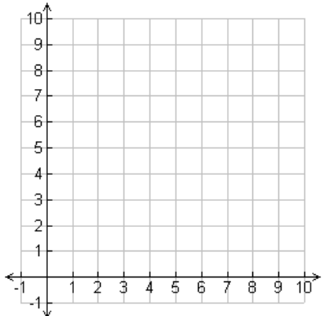
10. What is the area of the triangle? (A = $\frac{1}{2}$bh)

11. What is the perimeter of the triangle? (hint – you can use the distance formula or a² + b² = c² to help you!)

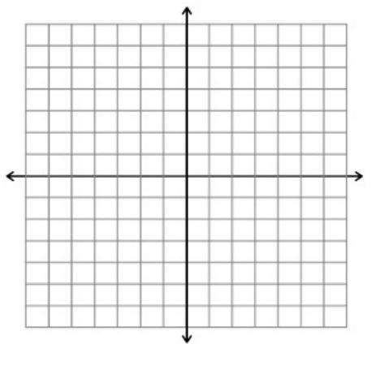
A quadrilateral has the vertices: A (-4, 5) B (7, 5) C (-4, -2) and D (7, 1).
12. What is the area of this shape?
Hints: triangle area: (A = $\frac{1}{2}$bh)
rectangle area A = bh

13. What is the perimeter of this shape? (you may use distance formula or a² + b² = c² to help you).

14. Circle all lines PARALLEL to y = - $\frac{1}{4}$x + 8
Y = 4x + 2 y = $\frac{1}{4}$x – 7 y = -4x + 9 y = - $\frac{1}{4}$x + 2
Y = - $\frac{1}{4}$x – 8 y = 4x + 8 y = 2x – 10 y = $\frac{1}{4}$ + 1
15. circle all lines PERPENDICULAR to y = $\frac{4}{5}$x – 3
Y = $\frac{5}{4}$x + 2 y = - $\frac{5}{4}$x – 3 y = $\frac{4}{5}$x + 2 y = - $\frac{5}{4}$x + 6

16. Write an equation of a line parallel to y = 2x + 1 through (-1, -4) you can use an equation to solve for b or graph.

17. Write an equation of a line parallel to y = $\frac{1}{3}$x – 6 through (6, 3) you can use an equation to solve for b or graph.

18. Write an equation of a line perpendicular to y = 2x + 3 through (4, -2) you can use an equation to solve for b or graph.

19. Write an equation of a line perpendicular to y = - $\frac{1}{3}$x + 2 through (-3, -6). you can use an equation to solve for b or graph.

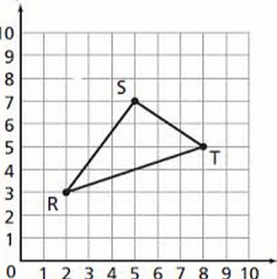
20. Find the midpoint of segment RT

