Unit 2 Review for Test Day 1

1. What are the 3 undefined terms in geometry? __________, ___________, ________
2. What is the formal definition of the following terms in geometry?

Segment ___________________________________________________________________

Angle ______________________________________________________________________

Perpendicular Lines ___________________________________________________________

Parallel Lines ________________________________________________________________

Show an example of the symbols used to name them and draw a precise picture using tools and marks.

|  |  |
| --- | --- |
| Line Segment Symbol | Picture |
| Angle Symbol | Picture |
| Perpendicular Lines Symbol | Picture |
| Parallel Lines Symbol | Picture |

Use the following colors to show that you understand the angle relationships.

1. 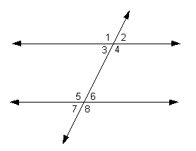Green AIA Red AIA 5. Blue SSIA Yellow SSIA 6. Green Red Yellow Blue CA

7. Define congruent angles. ______________________________________________________

Define Supplementary Angles _____________________________________________________

8. Look at the picture. List the angle relationship (AIA, AEA, SSIA, SSEA, CA) and whether they are congruent or supplementary.

a. $∠1 and∠5$______________ & _______________

b. $∠3 and<6$______________ & _______________

c. $<3 and∠5$______________ & _______________

d. $∠4 and∠5$______________ & _______________

e. $∠2 and∠6$______________ & _______________

f. $∠2 and∠8$______________ & _______________

g. $∠3 and∠7$______________ & _______________

h. $∠4 and∠6$______________ & _______________

i. $∠1 and∠8$______________ & _______________

j. $∠1 and∠7$______________ & _______________

k. $∠4 and∠8$______________ & _______________

l. $∠2 and∠7$______________ & _______________

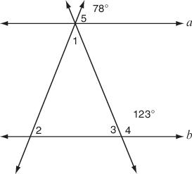9. What are the measures of the following angles?

75®

Be sure to use whatever angle relationships you know. For example: AIA, VA, Linear Pairs.

80®

$$m∠1= m∠2= m∠4=$$

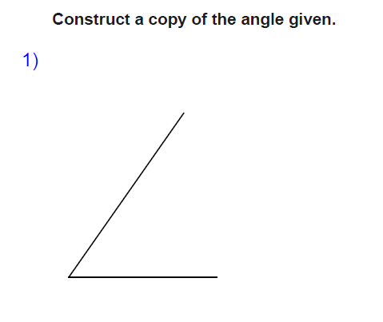10. Know all of the steps for the following constructions: copy an angle, angle bisector, perpendicular bisector. If you need extra practice with learning the steps, go to mathopenref.com to view all of the videos we used as support in class. Write out the steps you use to complete each construction. Be sure to use variables so that you can identify the steps correctly.

Steps:

1.

a.

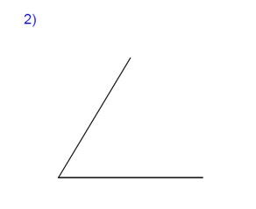

Steps:

1.

Construct the angle bisector.

b.

Construct a perpendicular line

Steps:

1.

c.

through the given point.

11. Find the midpoints using the midpoint formula. You MUST memorize the midpoint formula for the test. Write the formula correctly in the box before you begin the problems.

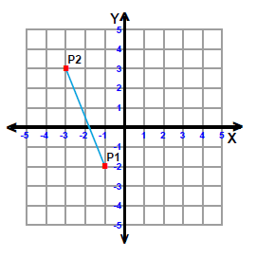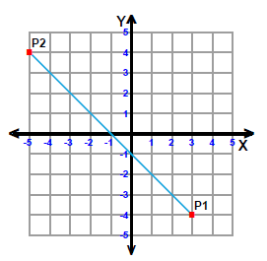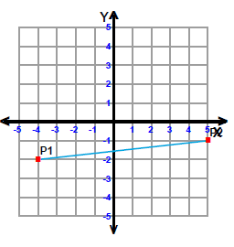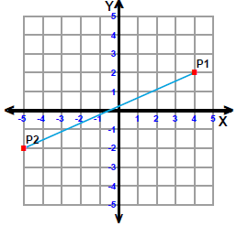

Midpoint Formula:

Make sure to plot each of your answers to see that they am actually make sense with the problem.

[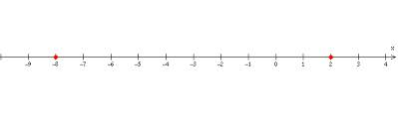](http://www.google.com/imgres?safe=active&sa=X&biw=1360&bih=724&tbm=isch&tbnid=LZmWDlM-89sacM:&imgrefurl=http://www.algebra.com/algebra/homework/Inequalities.faq.question.187773.html&docid=LjvfqU14hb04VM&imgurl=http://i150.photobucket.com/albums/s91/jim_thompson5910/Algebra%20dot%20com/number_line.png&w=632&h=200&ei=gAN4UtnCBqmfyQG8loHADA&zoom=1&ved=1t:3588,r:42,s:0,i:216&iact=rc&page=3&tbnh=113&tbnw=358&start=35&ndsp=21&tx=200&ty=58)M=____________ M=_____________ M=___________ M=_________

12. Find the midpoint on a number line.

M=_______________

[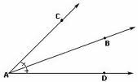](http://www.google.com/imgres?safe=active&sa=X&biw=1360&bih=724&tbm=isch&tbnid=962O_QWp57KaSM:&imgrefurl=http://www.icoachmath.com/math_dictionary/Angle_Bisector_Postulate.html&docid=ytiSc4rhP8zshM&imgurl=http://www.icoachmath.com/image_md///Angle%20Bisector%20Postulate1.jpg&w=212&h=127&ei=-ep3UqOhDYGwyQHIiYCQDg&zoom=1&ved=1t:3588,r:24,s:0,i:162&iact=rc&page=2&tbnh=101&tbnw=169&start=18&ndsp=24&tx=94&ty=54)Use the picture to the right to find x and $m<CAD.$

13. $m∠CAB=10x-4 and m∠DAB=3x+17$

X=_____________

[](http://www.google.com/imgres?safe=active&sa=X&biw=1360&bih=724&tbm=isch&tbnid=962O_QWp57KaSM:&imgrefurl=http://www.icoachmath.com/math_dictionary/Angle_Bisector_Postulate.html&docid=ytiSc4rhP8zshM&imgurl=http://www.icoachmath.com/image_md///Angle%20Bisector%20Postulate1.jpg&w=212&h=127&ei=-ep3UqOhDYGwyQHIiYCQDg&zoom=1&ved=1t:3588,r:24,s:0,i:162&iact=rc&page=2&tbnh=101&tbnw=169&start=18&ndsp=24&tx=94&ty=54)14. $m∠CAB=5x+2 and m∠DAB=8x-10$

X= $m∠CAD= ___________________$

_____________

Use the picture to the right. Find X, the length of $\overline{AM}$, the length of $\overline{BM}$, and the length of $\overline{AB}$.

15.

[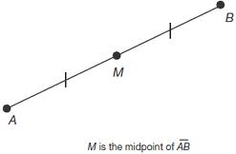](http://www.google.com/imgres?safe=active&biw=1360&bih=724&tbm=isch&tbnid=jP0qy4FQiquszM:&imgrefurl=http://www.education.com/reference/article/geometry1/&docid=ZUp0nz2j05z-6M&imgurl=http://00.edu-cdn.com/files/static/learningexpressllc/9781576856536/GEOMETRY_11.GIF&w=309&h=203&ei=TgR4UpA2xvjIAey8gZgL&zoom=1&ved=1t:3588,r:32,s:0,i:183&iact=rc&page=2&tbnh=162&tbnw=247&start=20&ndsp=22&tx=143&ty=79)

X= $\overline{AM}=__________ \overline{BM}=$

__________ ________

16. $\overline{AM}=7x+15, \overline{BM}=10x$

X= $\overline{AM}=__________ \overline{BM}=$

__________ ________

|  |  |  |  |  |
| --- | --- | --- | --- | --- |
| **17** | Which line is **NOT parallel** to the following line:  **Y = 3x + 7** | | | |
|  | **A** | y = 3x + 9 | **C** | y = 3x - 7 |
|  | **B** | y = 7x + 5 | **D** | y = 3x |

|  |  |  |  |  |
| --- | --- | --- | --- | --- |
| **18** | Which line is **perpendicular** to the following line:  **y = - $\frac{6}{7}$ x + 12?** | | | |
|  | **A** | y = - $\frac{6}{7}$ x – 4 | **C** | y = - $\frac{7}{6}$ x + 12 |
|  | **B** | y = $\frac{7}{6}$ x + 12 | **D** | y = $\frac{6}{7}$ x – 5 |

|  |  |  |  |  |
| --- | --- | --- | --- | --- |
| **19** | Write the equation of the line that is **parallel** to y = - $\frac{1}{2}$ x + 3 through (4, -1)? You may solve an equation or use a graph to solve for b.  Hint: y = mx + b  http://www.mathipedia.com/CoordinatePairsandGraphing_files/image005.gif | | | |
|  | **A** | y = - x + 1 | **C** | y = - $\frac{1}{2}$ x +3 |
|  | **B** | y = - $\frac{1}{2}$ x – 1 | **D** | y = - $\frac{1}{2}$ x + 5 |

|  |  |  |  |  |
| --- | --- | --- | --- | --- |
| **20** | Write the equation of the line that is **perpendicular** to y = - $\frac{1}{2}$ x + 3 through (2, 1)? You may solve an equation or use a graph to solve for b.  Hint: y = mx + b  http://www.mathipedia.com/CoordinatePairsandGraphing_files/image005.gif | | | |
|  | **A** | y = -2x + 5 | **C** | y = 2x + 1 |
|  | **B** | y = -2x – 4 | **D** | y = 2x - 3 |

|  |  |  |  |  |
| --- | --- | --- | --- | --- |
| **21** | (13, 2)  (13, 16)  (5, 2)  (5, 16) | | | |
|  | **A** | 84 | **C** | 112 |
|  | **B** | 66 | **D** | 44 |

|  |  |  |  |  |
| --- | --- | --- | --- | --- |
| **22** | A triangle has the following vertices:  http://www.mathipedia.com/CoordinatePairsandGraphing_files/image005.gifA (-3, 2) B (4, 2) C (4, -4)  Find the perimeter and area of the triangle.  Hints:  Find the lengths of each side:  AB _____ BC _______ AC _______  http://www.moomoomath.com/distance.jpgUse the distance formula for any diagonal sides:  Perimeter = distance around the triangle (add all sides)  Area of a triangle: A = $\frac{1}{2}$ bh | | | |
|  | **A** | Perimeter = 21.5 units, Area = 42 units2 | **C** | Perimeter = 21.5 units, Area = 21 units2 |
|  | **B** | Perimeter = 22.2 units, Area = 42 units2 | **D** | Perimeter = 22.2 units, Area = 21 units2 |

|  |  |  |  |  |
| --- | --- | --- | --- | --- |
| **23** | Find the perimeter of the figure:  Hints:  Find all of the side lengths:  JK _____ JM ______ ML ______ LK ______  http://www.moomoomath.com/distance.jpgUse the distance formula for any diagonal sides:  Or a2 + b2 = c2  Perimeter = add up all of the sides | | | |
|  | **A** | Perimeter = 34 units | **C** | Perimeter = 64 units |
|  | **B** | Perimeter = 24 units | **D** | Perimeter = 48 units |

|  |  |  |  |  |
| --- | --- | --- | --- | --- |
| **24** | Find the area of the figure:  Hints:  Find all of the side lengths:  JK _____ JM ______ ML ______ LK ______  Area = split into a triangle and rectangle, find each area.  Triangle: A = $\frac{1}{2}$ bh  Rectangle: A = bh | | | |
|  | **A** | Area = 88 units2 | **C** | Area = 48 units2 |
|  | **B** | Area = 64 units2 | **D** | Area = 60 units3 |