Name _____________________________________Shapes of Algebra Day 1
Window – see different parts of the graph
Tableset – start your table at a value. vvvalidifferent value

Some basics:
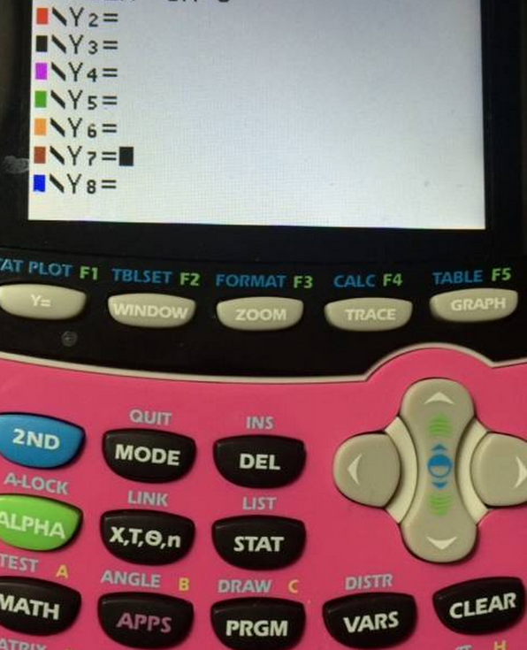
Calculate vertex, x-intercepts, other values (2nd, trace)
Enter an equation here (y =)

See the graph
Or the table (2nd then graph)

The variable (x)

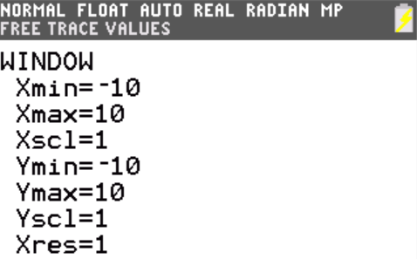
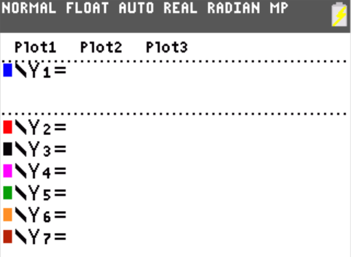
If you are graphing functions, make sure plots 1, 2, and 3 are NOT highlighted!

This is your default window. You may need to change it to see different parts of your graph.

Linear Functions
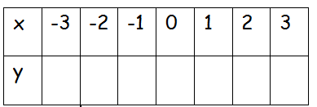
1. y = 2x – 4 2. y = - $\frac{1}{2}$x + 2 3. y = $\frac{1}{2}$x + 2

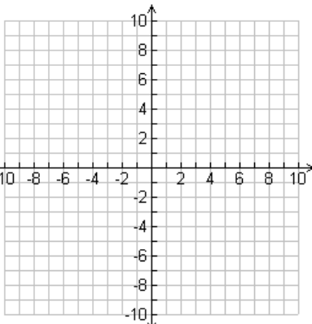
A. describe the patterns in the tables: ____________________________________________________________________________________________________________________________
B. describe the shape of the graphs: __________________________________
C. Which graph slopes down? What caused it to slope downward? ______________________________________________________________
General equation for a linear function: ____________________________
Linear tables _______________________________________________
Linear graphs _______________________________________________

Absolute value functions
1. y =$\left|x\right|$ 2. y = - $\left|x\right|$ - 1 3. y = $\left|x-1\right|$
A. describe the patterns in the tables: ____________________________________________________________________________________________________________________________
B. describe the shape of the graphs: __________________________________
C. Which graph opens down? What caused it to be flipped? ______________________________________________________________
General equation for an absolute value function: _____________________
Absolute value tables _______________________________________________
Absolute value graphs _______________________________________________

Quadratic functions
1. y = x² 2. y = -x² 3. y = $\frac{1}{2}$x² + 1

A. describe the patterns in the tables: ____________________________________________________________________________________________________________________________
B. describe the shape of the graphs: __________________________________
C. Which graph opens down? What caused it to be flipped? ______________________________________________________________
D. Which graph is wider than the others? What caused it to be wider? ______________________________________________________________
General equation for a quadratic function: _____________________
Quadratic tables _______________________________________________
Quadratic graphs _______________________________________________

Rational functions (*note, even though you are only recording 7 y values, use the table on your graphing calculator to plot additional points.)
1. y = $\frac{1}{x}$ 2. y = - $\frac{5}{x}$ 3. y = $\frac{3}{x}$
A. describe the patterns in the tables: ____________________________________________________________________________________________________________________________
B. describe the shape of the graphs: __________________________________
C. Why did you get an error message at x = 0? __________________________
General equation for a rational function: _____________________
Rational tables _______________________________________________
Rational graphs _______________________________________________

Exponential functions
1. y = 3^{x} 2. y = 1.5^{x} 3. y = 0.5^{x}
A. describe the patterns in the tables:
____________________________________________________________________________________________________________________________
B. describe the shape of the graphs: __________________________________
C. Which graph is decreasing? Why do you think it is this way?__________________________________________________________

General equation for an exponential function: _____________________
Exponential tables _______________________________________________
Exponential graphs _______________________________________________

Cubic functions
1. y = x³ 2. y = x³ + 2 3. y = -x³

A. describe the patterns in the tables: ____________________________________________________________________________________________________________________________
B. describe the shape of the graphs: __________________________________

General equation for a cubic function: _____________________
Cubic tables _______________________________________________
Cubic graphs _______________________________________________

Square root
1. y = $\sqrt{x}$ 2. y =(x + 2)^{.5} 3. y = $x^{\frac{1}{2}}$ – 2

A. describe the patterns in the tables: ____________________________________________________________________________________________________________________________
B. describe the shape of the graphs: __________________________________

General equation for a square root function: _____________________
Square root tables _______________________________________________
Square root graphs _______________________________________________

